

**Green University of Bangladesh**

**Department of Computer Science and Engineering(CSE) Faculty of Sciences and Engineering**

**Semester: (Spring, 2023), B.Sc. in CSE (Day)**

**LAB REPORT NO: 03**

**Course Title: Object Oriented Programing Lab**

**Course Code: CSE 202 Section: DE**

**Student Details**

|  |  |
| --- | --- |
| **Name** | **ID** |
| **Md. Moshiur Rahman** | **221902324** |

**Lab Date :** 15/03/2023

**Submission Date :** 22/03/2023

**Course Teacher’s Name : Dr. Muhammad Aminur Rahaman**

**[For Teachers use only: Don’t Write Anything inside this box]**

|  |
| --- |
| **Lab Report Status**  **Marks: ………………………………… Signature:..................... Comments:.............................................. Date :..........................** |

##### 

##### 1. TITLE OF THE LAB EXPERIMENT:

➤ 2 files contains 2 matrix, read from them and provide the matrix multiplication in the 3rd file.

##### 2. OBJECTIVES

➤ To implement such Java program which will be able to multiply two matrices and assign them to a third matrix when handling files.

##### 3. PROCEDURE

Step-1 : Creat a directory to store the files

Step-2 : Create three files: files 1, file 2, file 3

Step-3 : Initilize variable for matrix1, matrix2, matrix3 & mult.

Step-4 : Take input for number of rows & no. of coloumns of matrix1

Step-5 : Write matrix1 to file1 using a formatter object.

Step-6 : Take input for number of rows & no. of coloumns of matrix2

Step-7 : Write matrix2 to file2 using a formatter object.

Step-8 : If the number rows of matrix1 is equal to the number of columns of matrix2, perform matrix manipulation & store the result of mult

Step-9 : Write mult to file3 using a formatter object

Step-10 : Close all formatter object

Step-11 Display the result matrix

#### 4. IMPLEMENTATION

public class lab3 {

/

import java.io.File;

import java.util.Formatter;import java.util.Scanner;

public class LabReport {

public static void main(String[] args) {

java.io.File dir = new java.io.File("D:\\FileLocation\\person");

dir.mkdir();

File file1 = new File("D:\\FileLocation\\person\\mat1.txt");

File file2 = new File("D:/FileLocation/person/mat2.txt");

File file3 = new File("D:/FileLocation/person/mat3.txt");

try {

file1.createNewFile();

file2.createNewFile();

file3.createNewFile();

System.out.println("Files Are CREATED");

} catch (Exception e) {

System.out.println(e);

}

Scanner in = new Scanner(System.in);

int i, j, k, m1, n1, m2, n2;

int[][] matrix1 = new int[10][10];

int[][] matrix2 = new int[10][10];

int[][] mult = new int[10][10];

Scanner input = new Scanner(System.in);

System.out.print("Enter number of rows of matrix 1 : ");

m1 = in.nextInt();

System.out.print("Enter number of columns of matrix 1 : ");

n1 = in.nextInt();

try {

Formatter formatter = new Formatter("D:/FileLocation/person/mat1.txt");

System.out.println();

for (i = 0; i < m1; i++) {

for (j = 0; j < n1; j++) {

System.out.printf("Enter element of matrix 1[%d][%d]: ", i, j);

matrix1[i][j] = in.nextInt();

formatter.format("%d ", matrix1[i][j]);

}

formatter.format(" \r\n");

}

formatter.close();

} catch (Exception e) {

System.out.println(e);

}

System.out.println();

System.out.print("Enter number of rows of matrix 2 : ");

m2 = in.nextInt();

System.out.print("Enter number of columns of matrix 2 : ");

n2 = in.nextInt();

System.out.println();

try {

Formatter formatter = new Formatter("D:/FileLocation/person/mat2.txt");

//Scanner input = new Scanner(System.in);

if (m1 == n2) {

for (i = 0; i < m2; i++) {

for (j = 0; j < n2; j++) {

System.out.printf("Enter element of matrix 2[%d][%d]: ", i, j);

matrix2[i][j] = in.nextInt();

formatter.format("%d ", matrix2[i][j]);

}

formatter.format(" \r\n");

}

formatter.close();

} else {

System.out.println("Matrix multiplication not possible");

}

} catch (Exception e) {

System.out.println(e);

}

System.out.println();

System.out.println("\n....Your resultant matrix is....\n\n");

for (i = 0; i < m1; i++) {

for (j = 0; j < n2; j++) {

mult[i][j] = 0;

for (k = 0; k < m2; k++) {

mult[i][j] += matrix1[i][k] * matrix2[k][j];

}

}

}

try {

Formatter formatter = new Formatter("D:/FileLocation/person/mat3.txt");

//Scanner input=new Scanner(System.in);

for (i = 0; i < m1; i++) {

for (j = 0; j < n2; j++) {

System.out.printf("%d\t", mult[i][j]);

formatter.format("%d ", mult[i][j]);

}

System.out.println();

formatter.format("\r\n");

}

formatter.close();

} catch (Exception e) {

System.out.println(e);

}

}

}

}

#### 5. TEST RESULT:

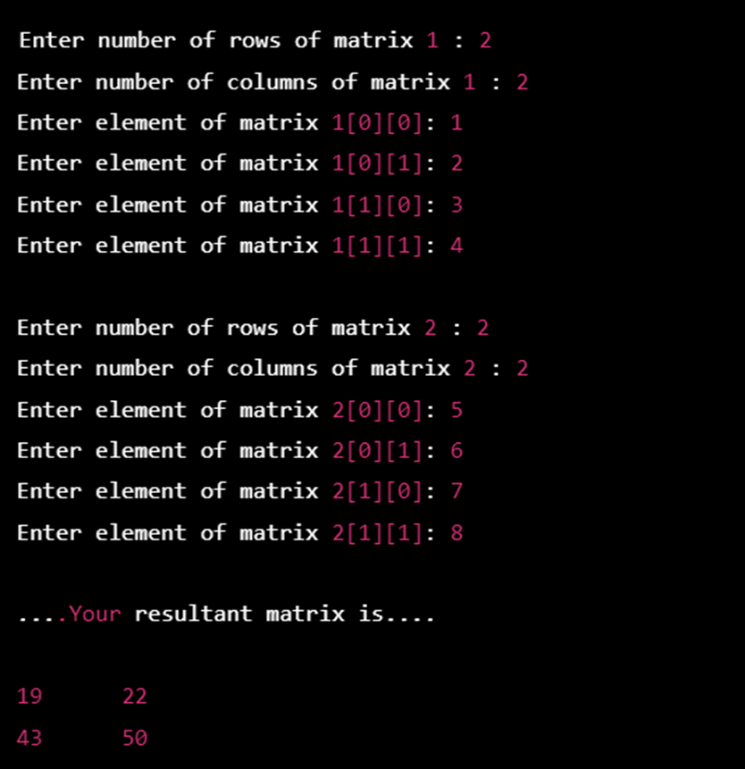

#### 

#### 6. ANALYSIS AND DISCUSSION:

The program is running well and showing the correct result. I have written all the algorithms in an easily understable way sequentially. So writing this program has become easy. The problem was very tough and also very time consuming. Writing algorithm of that problem was slightly complicated.The pseudocode is hard to complete but finally writing is done in the compiler but java-compilers have some technical issues so that output did not show. So I use online compiler to showing the output of the problem.